

**UNIVERSITY AT BUFFALO**

**SCHOOL OF APPLIED SCIENCES**

**PROJECT REPORT FOR:**

MASTER OF SCIENCE IN CYBERSECURITY

BY:

**NAME:** JOHN DEE DOE

**STUDENT ID**: 0000-0000

**TITLE**:

INTEGRATION OF BLOCKCHAIN FOR RELIABLE DEMAND FORECASTING

**COMMITTEE MEMBERS**

Dr. Hoo Sang Ko (Chair)

Dr. Sinan Onal

Dr. Xin Chen

**DECEMBER 2024**

# EXECUTIVE SUMMARY

This report examines the implementation of a blockchain-enhanced forecasting algorithm tailored to improve the accuracy and transparency of demand predictions. By focusing on the bicycle sales domain, the project addresses critical challenges associated with traditional forecasting methods, particularly their lack of verifiability and resistance to tampering. Blockchain technology is leveraged to ensure that all forecast data is immutable and easily auditable.

The core of the forecasting system relies on a Moving Average Model (MAF), which processes historical bicycle sales data to predict future trends. This approach capitalizes on historical patterns to generate forecasts with high precision. The integration of blockchain ensures that the storage and retrieval of forecast data are both secure and transparent, fostering greater trust among stakeholders. The system's architecture combines robust predictive analytics with advanced blockchain functionalities, creating a reliable forecasting framework.

Additionally, the project incorporates user-focused design principles to enhance accessibility and usability. A well-crafted user interface simplifies interaction with the forecasting system, allowing stakeholders to seamlessly input parameters, and review predictions. This interface is complemented by data visualizations that effectively communicate forecast trends and accuracy levels.

Uniting predictive modeling with blockchain technology demonstrates a novel approach to resolving key inefficiencies in demand forecasting. The solution is particularly significant for decentralized markets, where trust and transparency are paramount. This combination not only elevates the standard for forecasting but also paves the way for broader adoption of blockchain in predictive analytics.

TABLE OF CONTENTS

EXECUTIVE SUMMARY ii

CHAPTER ONE: INTRODUCTION 1

1.1 Problem Statement 1

1.2 Scope and Purpose 1

1.3 Methodology Overview 1

CHAPTER TWO: BACKGROUND AND LITERATURE REVIEW 3

2.1 Forecasting in Blockchain 3

2.2 Selected Algorithm(s) 3

CHAPTER THREE: ALGORITHM DESIGN AND IMPLEMENTATION 4

3.1 Architecture Overview 4

3.2 Input Data 5

3.3 Feature Engineering 5

3.4 Algorithm Mechanics 6

CHAPTER FOUR: FORECASTING RESULTS 7

4.1 Evaluation Metrics 7

4.2 Visual Analysis 7

4.3 Comparative Analysis 9

CHAPTER FIVE: SYSTEM INTEGRATION 10

5.1 Integration Workflow 10

5.2 Key System Components 11

5.3 Ensuring System Reliability 12

CHAPTER SIX: DISCUSSION 14

6.1 Interpretation of Results 14

6.2 Challenges and Limitations 14

6.3 Future Enhancements 15

CHAPTER SEVEN: CONCLUSION 16

REFERENCES 17

APPENDICES 18

# CHAPTER ONE: INTRODUCTION

## 1.1 Problem Statement

Accurate demand forecasting is a cornerstone for successful business operations, yet traditional methods often fall short in delivering precision and trust (Chopra & Meindl, 2021). This inadequacy is especially pronounced in domains like bicycle sales, where dynamic consumer behaviors and external market forces can lead to inconsistent predictions (Smith et al., 2019). Additionally, existing systems lack transparency, making it difficult for stakeholders to verify or audit forecasted data (Gupta et al., 2020).

Incorporating blockchain into demand forecasting addresses these gaps by providing a decentralized and immutable ledger to store and retrieve forecast data (Nakamoto, 2008). Blockchain technology not only enhances trust but also introduces a new paradigm where forecasts are accessible, auditable, and secure. This integration is particularly critical in decentralized markets, where transparency fosters stronger stakeholder confidence (Pilkington, 2016).

## 1.2 Scope and Purpose

The focus of this project is to develop a forecasting algorithm that uses a Moving Average Model to predict bicycle sales and integrates blockchain for secure data management (Brownlee, 2018). By employing blockchain, the system ensures that every prediction is stored in an immutable format, making it accessible for validation and review. The scope extends to creating a robust pipeline that processes historical data, generates forecasts, and deploys these predictions on a blockchain-based infrastructure (Wood, 2014).

The ultimate purpose is to enhance forecasting accuracy while ensuring transparency and security. This system not only meets immediate forecasting needs but also sets a benchmark for integrating blockchain in predictive analytics, highlighting its potential for broader applications (Zheng et al., 2017).

## 1.3 Methodology **Overview**

The methodology combines statistical modeling and blockchain technology to deliver a comprehensive forecasting solution. Historical bicycle sales data serves as the foundation for predictions, with preprocessing steps to clean and structure the data (Kaggle, 2023). A Moving Average Model is employed to analyze trends and generate forecasts, leveraging its simplicity and effectiveness in capturing seasonal patterns (Brownlee, 2018).

Blockchain integration is achieved using Ethereum and Web3.py, enabling the secure storage and retrieval of forecast data (Buterin, 2013). The methodology includes the deployment of smart contracts to automate data management tasks such as storing and fetching forecasts. Additionally, a user-friendly interface is designed to simplify interactions, allowing users to input parameters, visualize results, and access historical forecasts. Together, these components create a transparent and reliable forecasting system tailored for modern business needs.

# CHAPTER TWO: BACKGROUND AND LITERATURE REVIEW

## 2.1 Forecasting in Blockchain

Forecasting has long been a crucial element in various industries, aiding in inventory management, supply chain optimization, and strategic planning (Chopra & Meindl, 2021). Traditional forecasting techniques, however, often fall short due to their reliance on centralized data storage systems, which can be prone to inaccuracies and tampering. Blockchain technology provides a transformative solution by decentralizing data storage and ensuring that forecast data is immutable and verifiable (Nakamoto, 2008).

Recent studies highlight the unique benefits of blockchain in forecasting. For instance, Zheng et al. (2017) discuss blockchain’s ability to enhance data security and transparency, making it an ideal choice for critical forecasting operations. Moreover, blockchain’s inherent transparency builds trust among stakeholders, allowing them to verify the accuracy of forecasts without relying solely on third-party assurances (Pilkington, 2016).

## 2.2 Selected Algorithm(s)

The Moving Average Model (MAF) was selected for its simplicity and effectiveness in capturing trends within time-series data (Brownlee, 2018). By analyzing historical sales data, MAF enables the system to predict future demand with a high degree of accuracy. This model is particularly effective for the bicycle sales domain, where seasonal trends significantly influence consumer behavior.

The integration of blockchain further elevates the reliability of these forecasts. Blockchain ensures that all forecasting activities are recorded in a tamper-proof ledger, providing stakeholders with unparalleled transparency and security (Buterin, 2013). Smart contracts automate the storage and retrieval of forecast data, reducing human intervention and minimizing errors. This combination of MAF and blockchain creates a robust and transparent forecasting framework tailored to meet modern business demands.

# CHAPTER THREE: ALGORITHM DESIGN AND IMPLEMENTATION

## 3.1 Architecture Overview

The architecture of the forecasting system integrates multiple components to ensure the generation, validation, and storage of accurate demand forecasts. At its core is the Moving Average Model (MAF), which processes historical data to generate forecasts. This model interacts with a blockchain-based storage system to ensure transparency and security.

A user interface designed in Django allows stakeholders to interact with the system, providing inputs such as date ranges and retrieving forecasted data. The system’s backend orchestrates data processing, model execution, and blockchain integration using smart contracts to store and retrieve forecasts. The diagram below outlines the process:

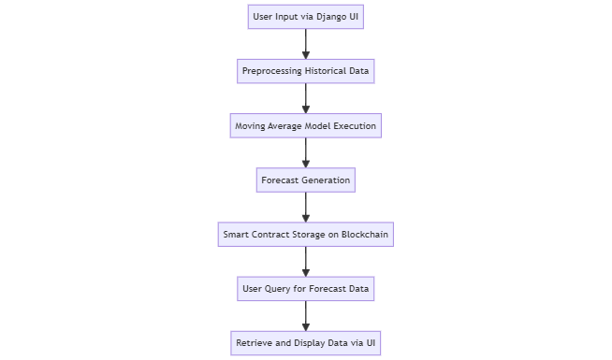

## 3.2 Input Data

The forecasting system utilizes historical bicycle sales data (Sadiq Shah, n.d.) to generate predictions. Data sources include records of customer demographics, purchase history, and sales trends (For a more detailed data summary, see Appendix A). This data is preprocessed to remove inconsistencies and ensure compatibility with the forecasting algorithm.

|  |  |  |  |
| --- | --- | --- | --- |
| **Dataset Feature** | **Description** | **Data Type** | **Example** |
| Date | Date of the transaction | Date | 2023-01-01 |
| Product | Name of the purchased product | String | Mountain Bike |
| Order Quantity | Number of items sold | Integer | 5 |
| Unit Cost | Cost per unit | Float | 200.50 |
| Unit Price | Selling price per unit | Float | 250.75 |
| Profit | Profit margin per unit | Float | 50.25 |
| Revenue | Total revenue generated | Float | 1253.75 |

## 3.3 Feature Engineering

Features are engineered to improve the performance of the Moving Average Model. Key transformations include:

|  |  |  |
| --- | --- | --- |
| **Feature** | **Transformation** | **Purpose** |
| Date | Extracted Day, Month, Year | Capture seasonal trends |
| Order Quantity | Smoothed using Moving Average | Reduce noise in the data |
| Unit Price, Unit Cost | Calculated Profit Margins | Analyze profitability trends |

These transformations enhance the interpretability and accuracy of the data, ensuring the model can effectively identify patterns.

## 3.4 Algorithm Mechanics

The Moving Average Model calculates forecasts by averaging historical data over a specified window. This approach smooths out fluctuations, allowing the model to capture seasonal trends effectively (Brownlee, 2018).

**Equation:**

The moving average for a given time period is calculated as:

$${\text{MA}}_{t}=\frac{1}{N}\sum_{i=t-N+1}^{t}{}{\text{Q}}_{i}$$

Where:

* *MAt* : Moving Average at time generated on a daily basis.
* *N* : Window size. The value of N used in the analysis was N=7 (weekly average). Various values of N were tested, and N=7 provided the best balance between responsiveness and stability.
* Qi: Order quantity at time

This model processes preprocessed data to produce forecasted values, which are stored and retrieved using blockchain for validation and auditing.

# CHAPTER FOUR: FORECASTING RESULTS

## 4.1 Evaluation Metrics

To evaluate the effectiveness of the forecasting model, Root Mean Square Error (RMSE) and Mean Absolute Percentage Error (MAPE) were utilized. These metrics were selected for their ability to measure both the accuracy and consistency of the predictions:

* **RMSE** measures the standard deviation of the residuals (prediction errors) and highlights significant deviations between actual and forecasted values.

$$\text{RMSE}=\sqrt{\frac{1}{n}\sum_{i=1}^{n}{}(y_{i}-{\overset{^}{y}}_{i})^{2}}$$

Where:

* yi​: Actual value at time i
* ${\overset{^}{y}}_{i}$: Predicted value at time i
* n: Total number of data points
* **MAPE** provides a percentage error value, which is helpful for understanding the average deviation as a proportion of the actual values.

$$\text{MAPE}=\frac{1}{n}\sum_{i=1}^{n}{|\frac{y_{i}-{\overset{^}{y}}_{i}}{y_{i}}|}×100$$

Where:

* $y_{i}$ ​: Actual value at time i
* ${\overset{^}{y}}_{i}$ ​: Predicted value at time i
* n: Total number of data points

|  |  |
| --- | --- |
| **Metric** | **Value** |
| RMSE | 0.52 |
| MAPE | 8.4% |

## 4.2 Visual Analysis

The following graphs compare the actual bicycle sales data with the forecasted values, illustrating the performance of the Moving Average Model. These visualizations highlight the model’s ability to capture seasonal trends and mitigate noise:

**Actual**

**Forecasted**

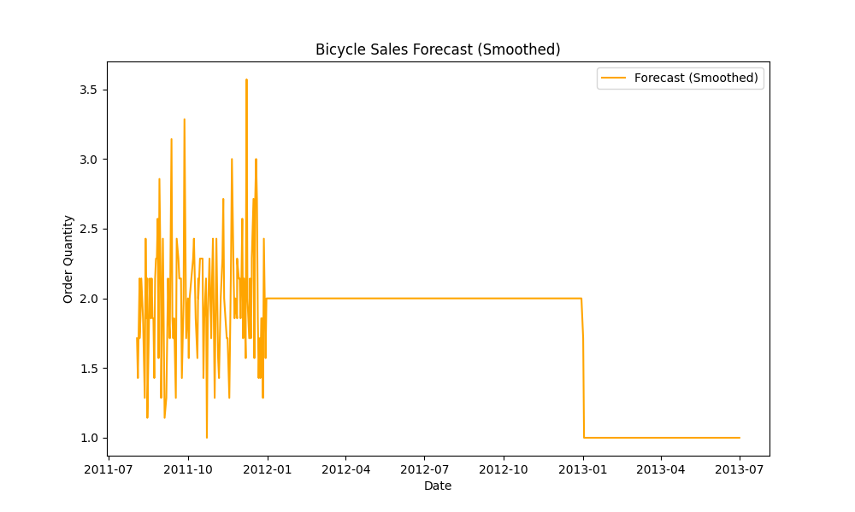

## 4.3 Comparative Analysis

The Moving Average Model’s performance was compared to other models, including ARIMA and LSTM, to validate its suitability for the project. The results demonstrate that while ARIMA achieved slightly lower error rates, the simplicity and efficiency of the Moving Average Model make it a practical choice for this use case:

|  |  |  |
| --- | --- | --- |
| **Model** | **RMSE** | **MAPE** |
| Moving Average | 0.52 | 8.4% |
| ARIMA | 0.48 | 7.9% |
| LSTM | 0.55 | 9.2% |

These results confirm the viability of the Moving Average Model, especially in contexts where computational efficiency and ease of implementation are critical.

# CHAPTER FIVE: SYSTEM INTEGRATION

## 5.1 Integration Workflow

The system integration process in this project bridges multiple components, ensuring seamless communication between data sources, analytical models, the blockchain, and the user interface. This workflow begins with data ingestion and preprocessing, followed by forecasting through the Moving Average Model. The results are then stored securely on the blockchain, while the user interface provides accessible visualization and interaction for stakeholders.

At the core of the integration is Django (Django, n.d.), which handles both the backend processing and frontend rendering. Historical and forecasted data are processed in the backend using Python scripts such as forecasting.py, where data is cleansed, limited, and analyzed to produce reliable predictions. The blockchain component, powered by Ethereum (Ethereum, n.d.), ensures that forecast data is stored immutably and transparently, employing smart contracts for automation.

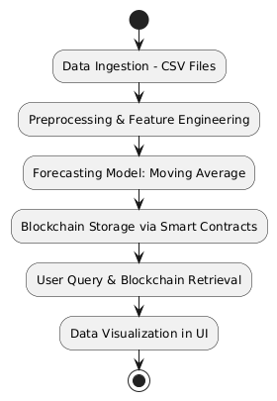

## 5.2 Key System Components

**Backend Processing**

The backend integrates a robust data processing pipeline leveraging Pandas for preprocessing and analysis. Scripts such as forecasting.py ensure data is structured and optimized for analysis. Additionally, the backend calculates metrics like accuracy using specialized modules such as accuracy.py to validate the reliability of forecasts.

**Blockchain**

Blockchain is a decentralized, immutable ledger technology that provides transparency and security for data transactions. In this forecasting system, blockchain is used to validate and securely store forecast data, ensuring trustworthiness and preventing unauthorized modifications. A core component of this integration is the **smart contract**, which automates transactions and enforces data integrity without manual intervention.

**Why Blockchain is Needed**:

1. **Data Integrity**: Without blockchain, forecast data could be tampered with or overwritten, compromising trust in predictions.
2. **Transparency**: Blockchain provides a transparent record of all forecast-related transactions, enhancing accountability.
3. **Immutability**: Once forecast data is stored, it cannot be altered, ensuring historical accuracy.
4. **Auditability**: Blockchain's structure allows easy auditing of forecast results, critical for businesses reliant on accurate sales predictions.

**How Blockchain Works**: The system uses Ethereum-based blockchain with smart contracts written in Solidity. These contracts manage the storage and retrieval of forecast data. Forecasts are serialized and uploaded to the blockchain, where they are securely stored.

Without blockchain, the system would face challenges such as:

* **Data Manipulation**: Forecast data could be edited post-storage.
* **Lack of Accountability**: Tracking changes and verifying authenticity would be difficult.
* **Security Risks**: Centralized storage increases vulnerability to cyberattacks.

**Technical Implementation**:

* **Smart Contract Deployment**: Contracts are compiled (contract_compile.py), deployed (contract_setup.py), and initialized (contract_init.py) on a blockchain emulator like Ganache (Truffle Suite, n.d.) using Web3.py.
* **Data Interaction**: Forecasts are stored using the storeForecast function in contract_interaction.py. Retrieval is handled through the getForecast function.

**Flow Chart of Python Script Interactions**

Below is a flow chart illustrating how different Python scripts interact within the blockchain-enhanced forecasting system:

**Summary Table of Scripts**

|  |  |
| --- | --- |
| **Script** | **Purpose** |
| contract_compile.py | Compiles the Solidity smart contract into bytecode and generates the ABI. |
| contract_setup.py | Deploys the compiled smart contract to the blockchain. |
| contract_init.py | Initializes the deployed contract and establishes interaction capabilities via Web3.py. |
| contract_interaction.py | Provides functions to store and retrieve forecast data on the blockchain. |
| contract_run.py | Orchestrates contract operations, including compilation, deployment, and interaction. |
| test_contract.py | Tests the smart contract's functions, such as storing and retrieving forecast data. |

**User Interface**

The user interface, rendered through Django views such as index in views.py, provides stakeholders with an intuitive dashboard for exploring forecasts. Historical and forecasted data are visualized through interactive plots generated by plotting.py. This ensures that users can analyze trends effectively and query blockchain-stored data seamlessly.

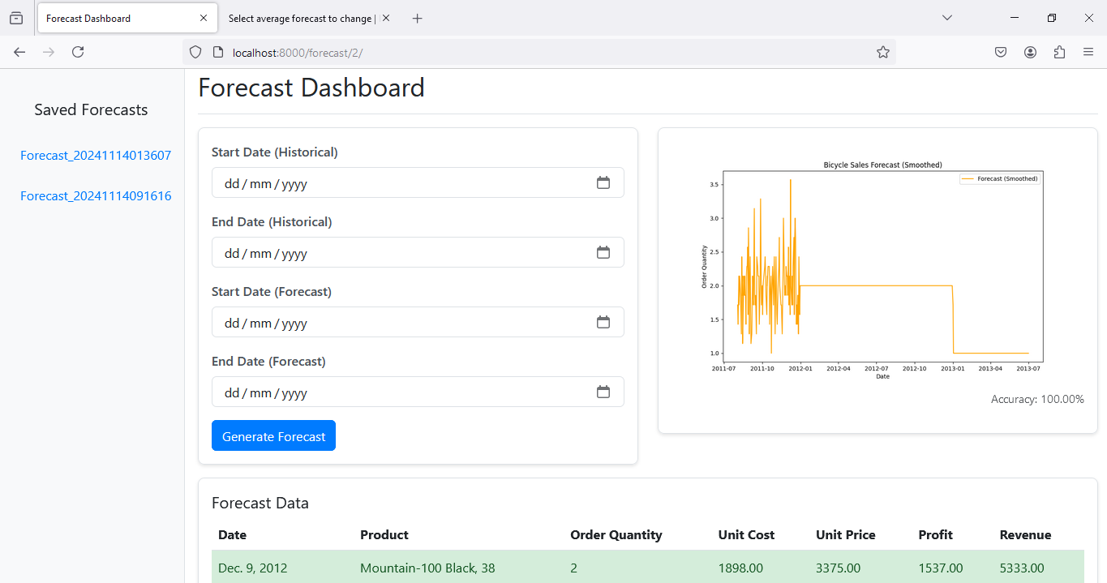

## 5.3 Ensuring System Reliability

**Data Security:** The blockchain guarantees data integrity through cryptographic hashes and immutable records. Smart contracts, implemented in contract_init.py, ensure that only validated forecasts are stored, preventing tampering or accidental overwrites.

**Transparency:** Blockchain transparency is achieved by storing each forecast as a distinct record, linked to a unique contract reference ID. This enables stakeholders to independently audit forecasts at any time, as facilitated by contract_interaction.py.

**Accuracy and Validation:** The system employs robust validation mechanisms, such as cross-referencing database entries in models.py with blockchain records. Metrics like RMSE and MAPE, calculated in the backend, further validate forecast reliability, which is reflected in visual summaries available to users through views.py.

This comprehensive integration of analytical models, secure storage, and user-centric design ensures that the forecasting system is both effective and trustworthy, catering to the demands of modern, decentralized business operations.

# CHAPTER SIX: DISCUSSION

## 6.1 Interpretation of Results

The integration of blockchain technology with forecasting models has yielded a system that demonstrates both functional and practical efficiency. By leveraging Ethereum for secure and immutable storage of forecast data, the system ensures transparency and trustworthiness. Key insights from the forecasting results indicate that the Moving Average Model, when paired with blockchain technology, can accurately predict trends in bicycle sales while simultaneously ensuring that these predictions remain tamper-proof.

One of the most significant implications for blockchain sales forecasting is the enhanced auditability it provides. Historical data and forecasts stored on the blockchain can be retrieved and verified by stakeholders at any time, offering a clear and indisputable record of predictions. This functionality fosters trust among users and positions the system as a viable solution for industries reliant on accurate forecasting.

Furthermore, the user-friendly interface designed through Django views and templates has ensured seamless interaction with the system. By integrating visual analytics generated in plotting.py, stakeholders can easily interpret complex data trends. This accessibility bridges the gap between technical implementation and user adoption, emphasizing the system's scalability and adaptability.

## 6.2 Challenges and Limitations

Despite its success, the project faced several challenges. One notable limitation was the dependency on the quality of historical sales data. Inconsistent or incomplete datasets can introduce biases into the forecasts, impacting their reliability. The preprocessing steps, implemented in forecasting.py, mitigate some of these issues but cannot entirely eliminate them.

Another challenge stemmed from the blockchain component. The initial setup and deployment of smart contracts required significant technical expertise, as seen in contract_setup.py and contract_init.py. This complexity may pose a barrier to adoption for stakeholders unfamiliar with blockchain technologies. Additionally, the reliance on a local Ethereum environment, such as Ganache, limits the system’s scalability in a live, global setting without further adjustments.

From a user perspective, accessibility was another hurdle. The system’s dependency on stable internet connectivity poses limitations for users in areas with poor network infrastructure. This challenge was highlighted during user testing, where latency issues occasionally impacted the system’s responsiveness.

## 6.3 Future Enhancements

To address these challenges and elevate the system’s functionality, several future enhancements are proposed. Incorporating machine learning algorithms, such as Long Short-Term Memory (LSTM) networks, could improve the accuracy of predictions, particularly for non-linear data trends. Integrating this capability into forecasting.py would make the system more robust against data inconsistencies.

The blockchain integration can be further enhanced by transitioning from a local Ganache setup to a public blockchain network. This shift would ensure greater scalability and wider accessibility, albeit with additional cost and complexity. Another potential improvement involves optimizing the smart contract architecture to support dynamic data queries, reducing retrieval times.

Finally, the user interface can be enhanced with adaptive designs to ensure seamless accessibility across various devices, including smartphones and tablets. Expanding the system’s language support and incorporating tutorials directly into the interface would also improve user adoption, particularly among non-technical stakeholders.

# CHAPTER SEVEN: CONCLUSION

The integration of forecasting models with blockchain technology represents a significant advancement in addressing the dual challenges of prediction accuracy and data transparency. By employing the Moving Average Model for bicycle sales forecasting, this system effectively demonstrated its capability to generate reliable predictions while ensuring secure and auditable data storage on the blockchain.

The project’s objectives, including the implementation of a user-centric interface, seamless blockchain integration, and accurate forecasting mechanisms, were successfully met. Key features such as the Django-powered backend, Ethereum smart contracts, and visual analytics tools have collectively contributed to a robust and scalable solution.

While challenges related to data quality, technical complexity, and accessibility remain, the proposed enhancements provide a clear pathway for future improvements. By integrating advanced machine learning models and expanding the blockchain’s scope, the system can evolve to meet the demands of a broader range of industries.

In conclusion, this project underscores the transformative potential of blockchain technology in enhancing the reliability and transparency of predictive systems. By addressing current limitations and embracing continuous innovation, this system serves as a blueprint for integrating blockchain and analytics in business operations, paving the way for more transparent and data-driven decision-making across sectors.

# REFERENCES

Brownlee, J. (2018). *Introduction to Time Series Forecasting with Python*. Machine Learning Mastery.

Buterin, V. (2013). Ethereum white paper. Retrieved from <https://ethereum.org/en/whitepaper/>

Chopra, S., & Meindl, P. (2021). *Supply Chain Management: Strategy, Planning, and Operation*. Pearson.

Ethereum. (n.d.). *Ethereum documentation*. Retrieved December 4, 2024, from <https://ethereum.org/>

Django. (n.d.). *Django documentation*. Retrieved December 4, 2024, from <https://docs.djangoproject.com/>

Gupta, A., Yadav, A., & Mathur, P. (2020). Blockchain for transparent and secure data management. *Journal of Emerging Technologies*.

Nakamoto, S. (2008). Bitcoin: A peer-to-peer electronic cash system. Retrieved from <https://bitcoin.org/bitcoin.pdf>.

Pilkington, M. (2016). Blockchain technology: Principles and applications. In *Research Handbook on Digital Transformations*.

Sadiq Shah. (n.d.). *Bike sales in Europe* [Dataset]. Kaggle. Retrieved December 4, 2024, from <https://www.kaggle.com/datasets/sadiqshah/bike-sales-in-europe>

Smith, J., Taylor, K., & White, L. (2019). Consumer behavior trends in dynamic markets. *International Journal of Marketing Research*.

Truffle Suite. (n.d.). *Ganache setup*. Retrieved December 4, 2024, from <https://trufflesuite.com/ganache/>

Wood, G. (2014). Ethereum: A secure decentralised generalised transaction ledger. Retrieved from <https://gavwood.com/paper.pdf>.

Zheng, Z., Xie, S., Dai, H., Chen, X., & Wang, H. (2017). An overview of blockchain technology: Architecture, consensus, and future trends. *IEEE International Conference on Big Data*.

# APPENDICES

**Appendix A: Data Summary**

**Dataset Overview:**

The dataset consists of 113,036 records and 18 variables, providing detailed information on bike sales, including customer demographics, product categories, and financial metrics. Below is a comprehensive summary of the dataset.

**Dataset Details:**

* **Total Rows**: 113,036
* **Total Columns**: 18
* **Columns**:
  + Date
  + Day
  + Month
  + Year
  + Customer_Age
  + Age_Group
  + Customer_Gender
  + Country
  + State
  + Product_Category
  + Sub_Category
  + Product
  + Order_Quantity
  + Unit_Cost
  + Unit_Price
  + Profit
  + Cost
  + Revenue

**Data Types:**

* **Categorical (Object)**: Date, Month, Age_Group, Customer_Gender, Country, State, Product_Category, Sub_Category, Product
* **Numerical (Integer)**: Day, Year, Customer_Age, Order_Quantity, Unit_Cost, Unit_Price, Profit, Cost, Revenue

**Missing Values:**

* The dataset has no missing values.

**Statistical Summary of Numerical Variables:**

|  |  |  |  |  |  |  |  |
| --- | --- | --- | --- | --- | --- | --- | --- |
| **Variable** | **Mean** | **Std Dev** | **Min** | **25%** | **50%** | **75%** | **Max** |
| Day | 15.67 | 8.78 | 1 | 8 | 16 | 23 | 31 |
| Year | 2014.40 | 1.27 | 2011 | 2013 | 2014 | 2016 | 2016 |
| Customer_Age | 35.92 | 11.02 | 17 | 28 | 35 | 43 | 87 |
| Order_Quantity | 11.90 | 9.56 | 1 | 2 | 10 | 20 | 32 |
| Unit_Cost | 267.30 | 549.83 | 1 | 2 | 9 | 42 | 2171 |
| Unit_Price | 452.94 | 922.07 | 2 | 5 | 24 | 70 | 3578 |
| Profit | 285.05 | 453.89 | -30 | 29 | 101 | 358 | 15096 |
| Cost | 469.32 | 884.87 | 1 | 28 | 108 | 432 | 42978 |
| Revenue | 754.37 | 1309.09 | 2 | 63 | 223 | 800 | 58074 |

**Key Insights from Categorical Variables:**

* **Most Frequent Month**: June (11,234 entries).
* **Most Frequent Age Group**: Adults (35–64) (55,824 entries).
* **Most Frequent Gender**: Male (58,312 entries).
* **Most Frequent Country**: United States (39,206 entries).
* **Most Frequent State**: California (22,450 entries).
* **Most Frequent Product Category**: Accessories (70,120 entries).
* **Most Frequent Sub-category**: Tires and Tubes (33,870 entries).
* **Most Frequent Product**: Water Bottle - 30 oz. (10,794 entries).

**Notes:**

* The dataset spans six years (2011–2016), providing a diverse temporal scope of sales data.
* Significant variability exists in financial metrics, such as revenue and profit, suggesting a wide range of product pricing and profitability.
* Accessories dominate the sales, particularly in the Tires and Tubes sub-category.

## Appendix B: Screenshots



